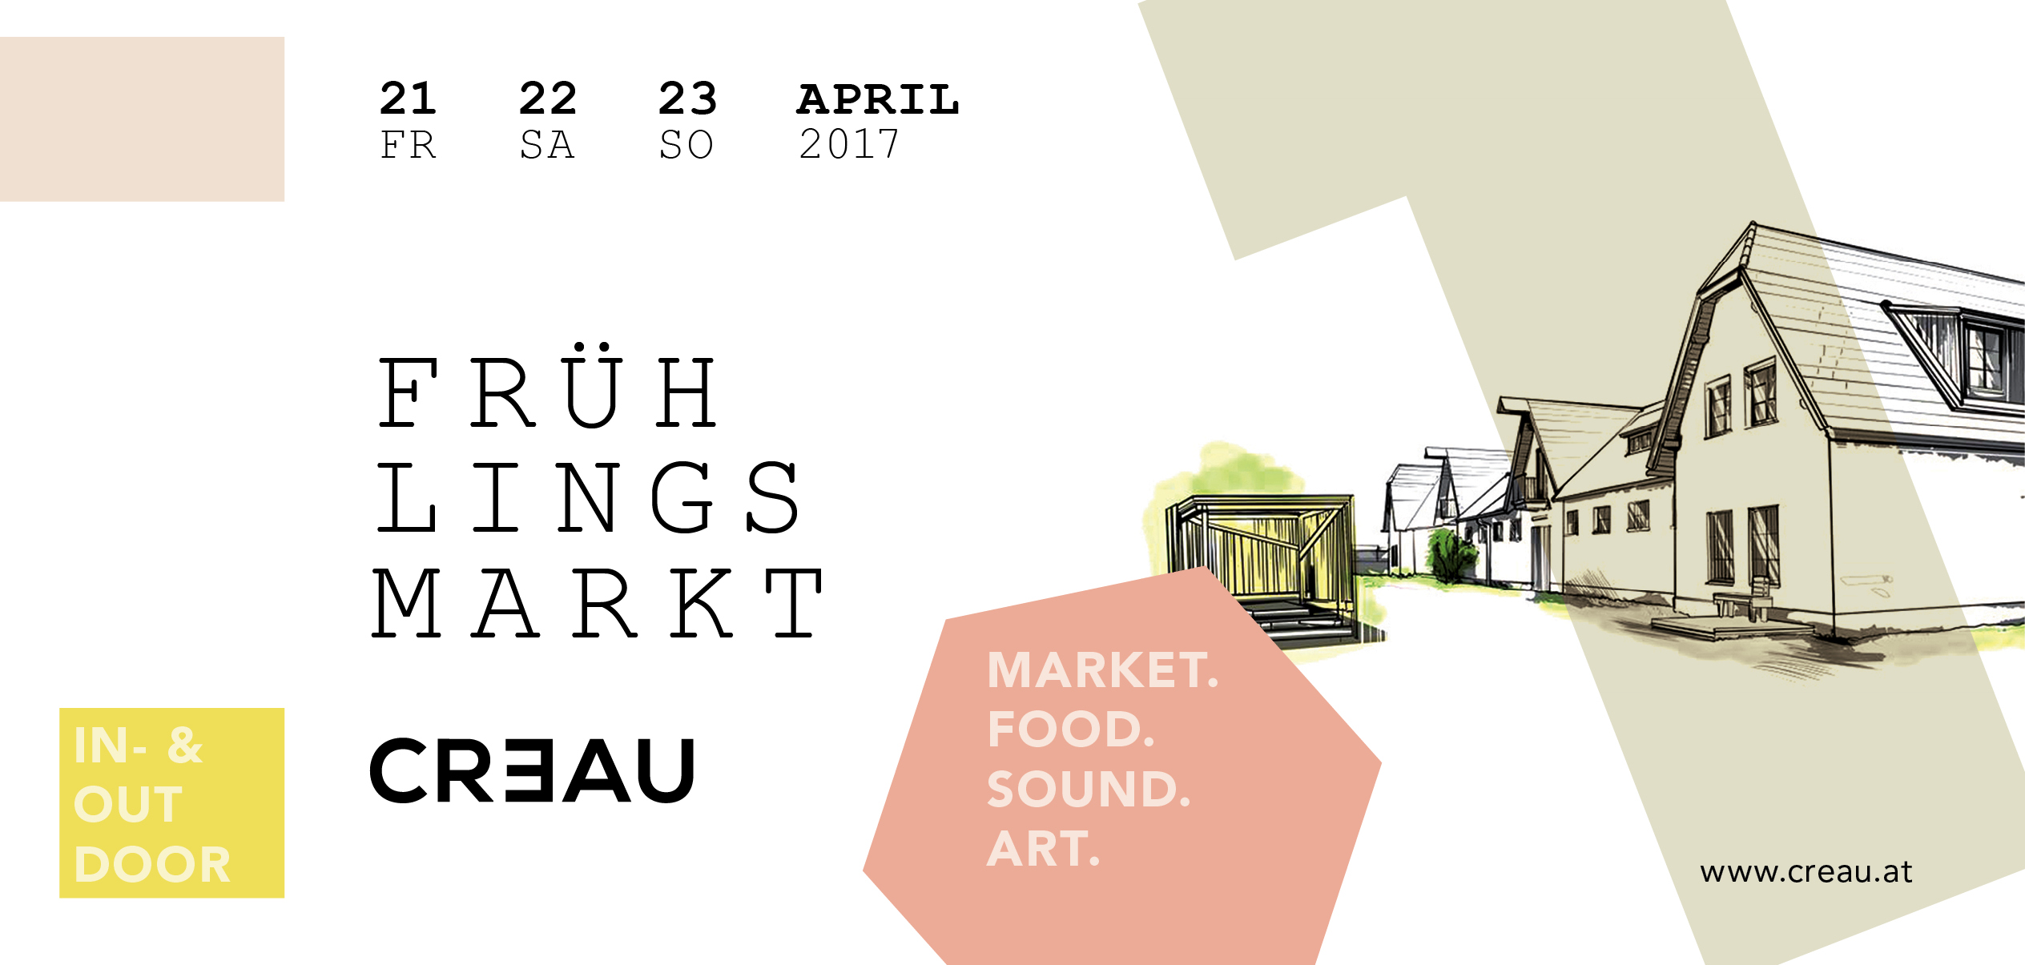

AUSTELLER_innen

Adamah BioHof / BioKistl
https://de-de.facebook.com/ADAMAH.BioHof/
www.adamah.at

Aircouch / Home & Living

Albizia / Pflanzen, Handgebundene Türkränzen
http://bougainsort.com

ants&pants / Home & Living, Accessoires, Mode
instagram.com/ants_and_pants/

Ampelpärchen Rocks / Home & Living, Mode
facebook.com/Ampelpaerchenrocks/
www.ampelpaerchen.rocks

ANTI-FORM / Kunst, Mode
facebook.com/ANTIXFORM
www.anti-form.com

Arion Jewelry / Schmuck, Mode
facebook.com/arionjewelry
instagram.com/arionjewelry

Das Beanchen / Accessoires, Mode
facebook.com/dasbeanchen
www.dasbeanchen.com

Black River Collective / Schmuck, Papeterie, Keramik
facebook.com/blackrivercollective/
http://artandthemaiden.tumblr.com

CauCawa • Ehrlicher Kakao / Delikatessen
facebook.com/caucawa/
instagram.com/caucawa.kakao/
www.caucawa.at

createur de sac / Accessoires

daisy chain oddities /
facebook.com/DaisyChainOddities
www.daisychainoddities.com

Edita Rosenrot / modern vintage jewellery & accessories
facebook.com/editarosenrotaccessories/
instagram.com/edita_rosenrot/
www.editarosenrot.com

FEIERTAG / Home & Living, Kunst

Frameshore / Home & Living, Kunst
instagram.com/frameshore/
www.frameshore.com

freulein kocht / Delikatessen
facebook.com/freuleinkocht
instagram.com/freuleinkocht
www.freuleinkocht.at

GREEN SHIRTS / Mode
facebook.com/GreenShirtsLabel/?fref=ts
www.green-shirts.com

LeStoff / Home & Living, Accessoires, Mode
facebook.com/lestoff
www.lestoff.eu

Litto / Kunst / Home & Living, Schmuck
facebook.com/litto2015/ /
www.Litto.work

Lio Jewelry / Accessoires, Schmuck, Mode
facebook.com/lio.works
www.lio.works

Nina Jerak - The Art of Sensual Dinnerware / Home & Living, Kunst, Keramik
www.ninajerak.com

Monika Palka / Kunst
instagram.com/piakolada/
http://monikapalka.wixsite.com/mysite

monkeyorchid / Home & Living, Accessoires, Schmuck, Kunst, Mode
www.josephinefaschinggray.at

Paprcuts / Accessoires, Kunst, Sachen aus Tyvek
facebook.com/Paprcuts/?fref=ts
www.paprcuts.de

RILLE FIX Night Bags / Accessoires, Mode
facebook.com/rillefix
shop.rillefix.com

SABORKA / Accessoires
facebook.com/SABORKA.at/
www.saborka.at

SIGH / Home & Living, Accessoires, Papeterie, Keramik
facebook.com/SIGH.Illustration
sigh-illustration.com

Vorms / Accessoires, Schmuck, Mode
facebook.com/vorms9/

